MODULE 5

- Capture and analyze ARP packets using Wireshark. Inspect the ARP request and reply frames, and discuss the role of the sender's IP and MAC address in these packets.
The sender IP and MAC address fields help devices update their ARP tables and enable proper communication in the network.
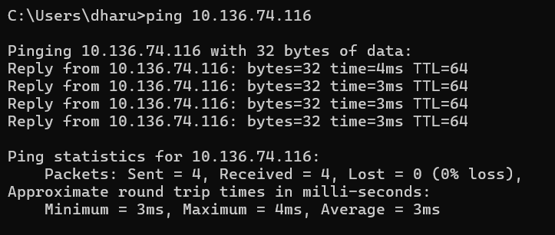
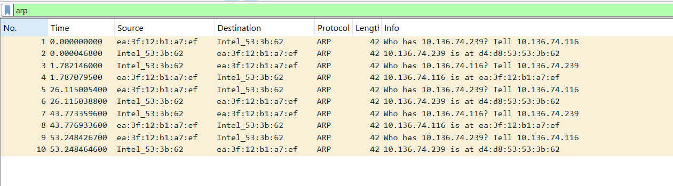
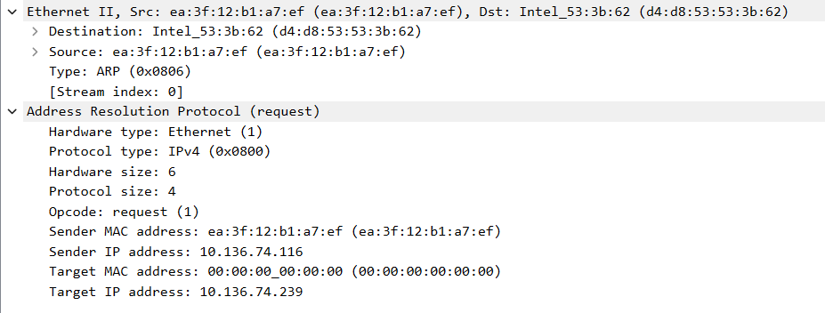
In the above figure, ARP request is sent by the device with IP 10.136.74.116 to find the MAC address of the device with IP 10.136.74.239.
Since the sender does not know the target MAC address, it is set to 00:00:00:00:00:00.
The ARP request is broadcast to all devices in the network.
The request basically means:
"Who has IP address 10.136.74.239? Tell 10.136.74.116"
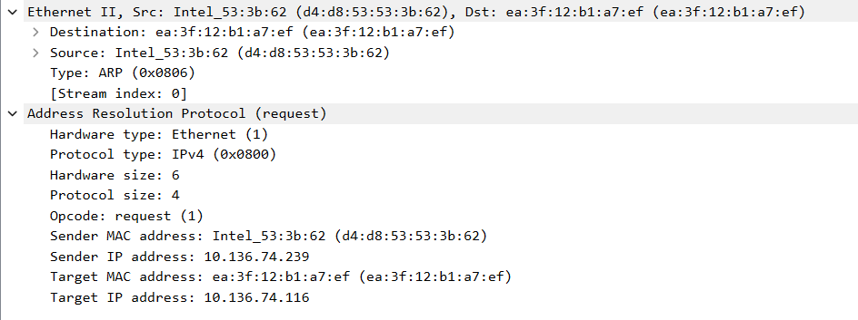

In the above figure, ARP reply is sent by the device with IP 10.136.74.239 to the device 10.136.74.116.
It provides its MAC address so that communication can occur.
The reply basically means:
"10.136.74.239 is at MAC d4:d8:53:53:3b:62"

- Using Packet Tracer, simulate an ARP spoofing attack. Analyze the behavior of devices on the network when they receive a malicious ARP response.

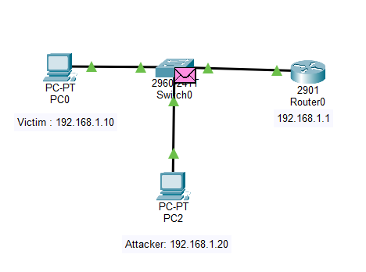

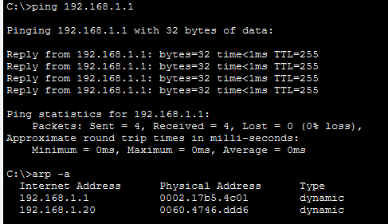

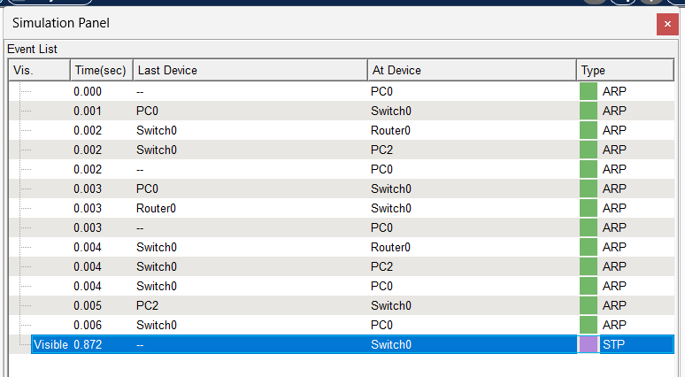
A network consisting of a victim PC, an attacker PC, a switch, and a router was created in Cisco Packet Tracer. Initially, the victim PC sent an ARP request to find the MAC address of the router. The router responded with an ARP reply containing its MAC address, and the victim updated its ARP table with the router’s MAC address. The ARP packets were observed in Simulation mode in Packet Tracer.
To simulate ARP spoofing, the attacker PC generated ARP traffic toward the victim PC. In a real ARP spoofing attack, the attacker would send a malicious ARP reply claiming that the router’s IP address corresponds to the attacker’s MAC address. Since ARP does not have authentication, the victim would update its ARP cache with the attacker’s MAC address, causing traffic to be redirected to the attacker.
When a device receives a malicious ARP reply, it updates its ARP cache with the MAC address provided in the ARP reply without verifying its authenticity. The device then sends packets to the attacker instead of the actual destination. This results in traffic interception, packet sniffing, or Man-in-the-Middle attacks.

- Manually configure static IPs on the client devices (like PC or your mobile phone) and verify connectivity using ping.
Before changing the static ip:
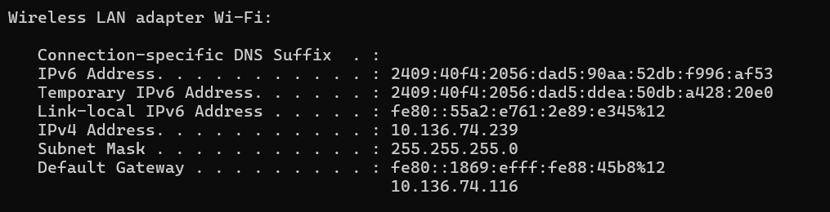
Changing the static ip:
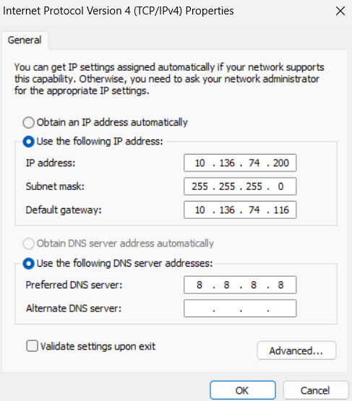

Pinging after the change of static ip:
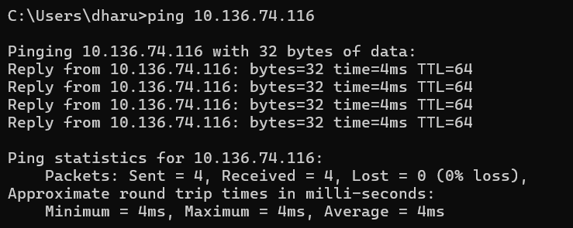

The modified ip address is now visible:
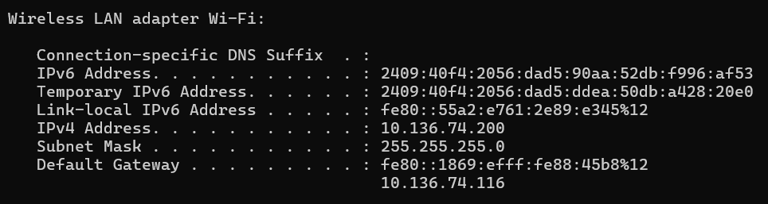

Inference:
Static IP addressing was successfully configured manually on the client device, and connectivity was verified using the ping command. Successful ping replies confirmed proper communication in the network using static IP configuration.
- Use Wireshark to capture DHCP Discover, Offer, Request, and Acknowledge messages and explain the process.

Dynamic Host Configuration Protocol (DHCP) is used to automatically assign IP addresses to devices in a network. The DHCP process consists of four steps known as DORA: Discover, Offer, Request, and Acknowledge. First, the client sends a DHCP Discover message as a broadcast to find a DHCP server. The DHCP server responds with a DHCP Offer message containing an available IP address. The client then sends a DHCP Request message to request the offered IP address. Finally, the DHCP server sends a DHCP Acknowledge message confirming the IP address assignment. After this process, the client is assigned an IP address and can communicate on the network.
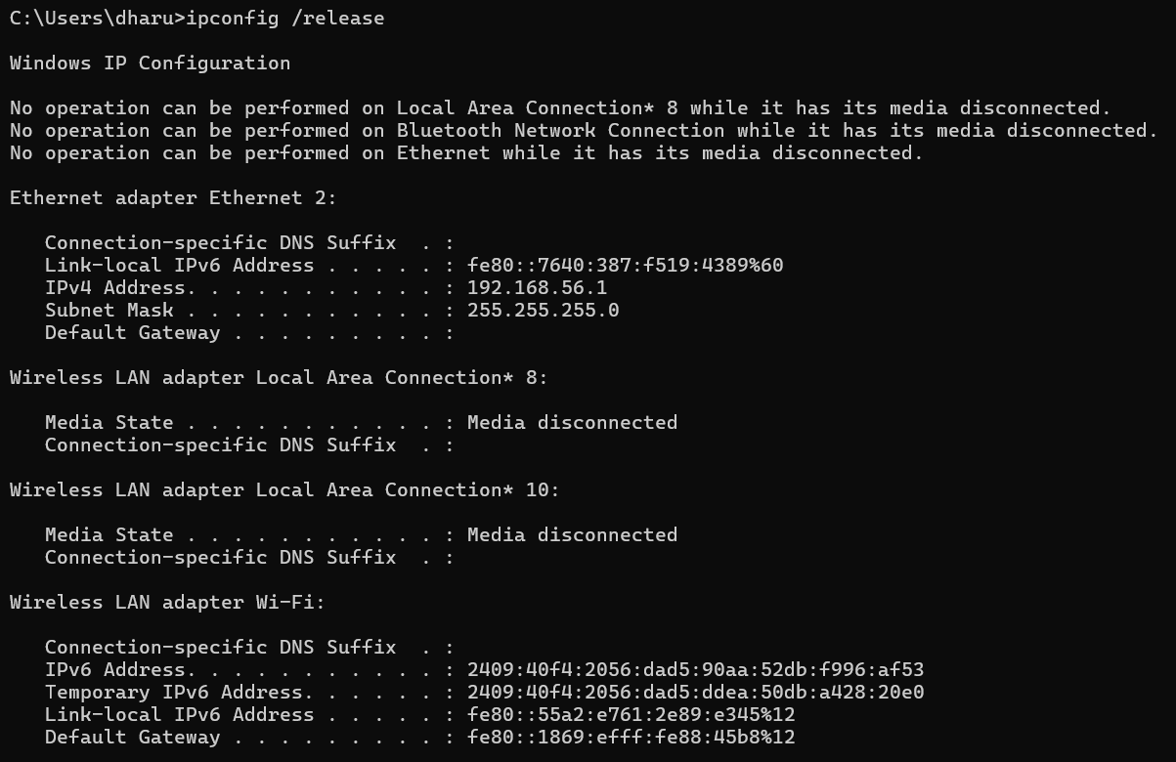
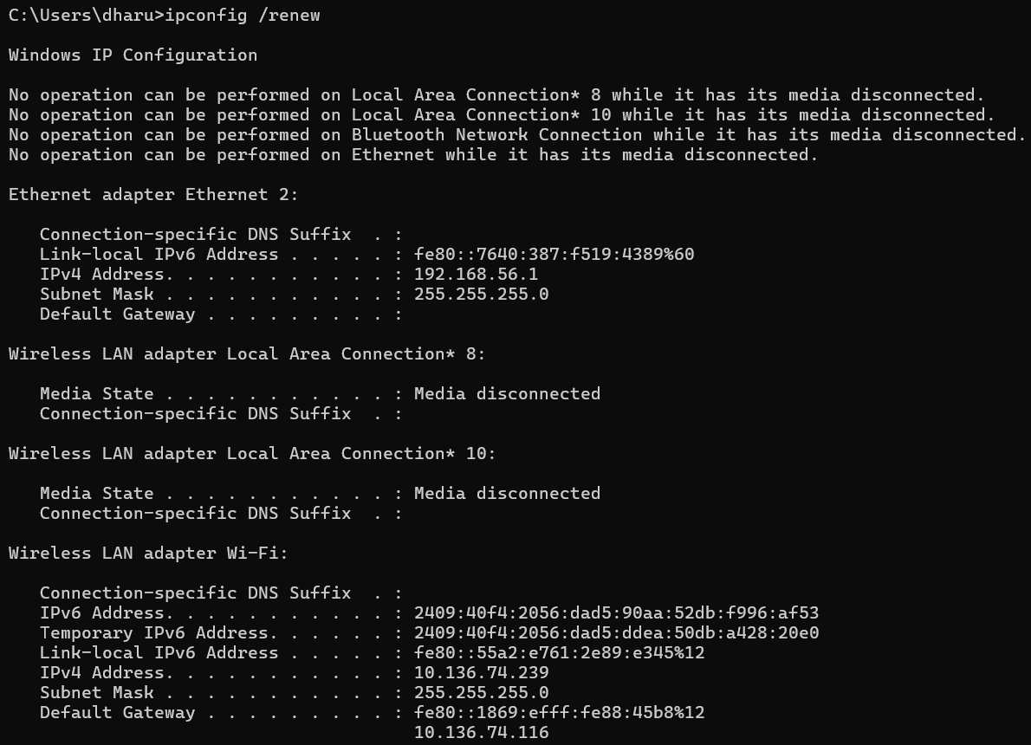

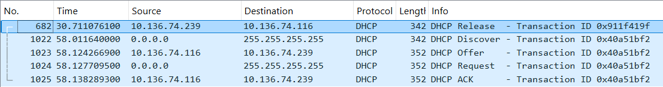

DHCP – DISCOVER:

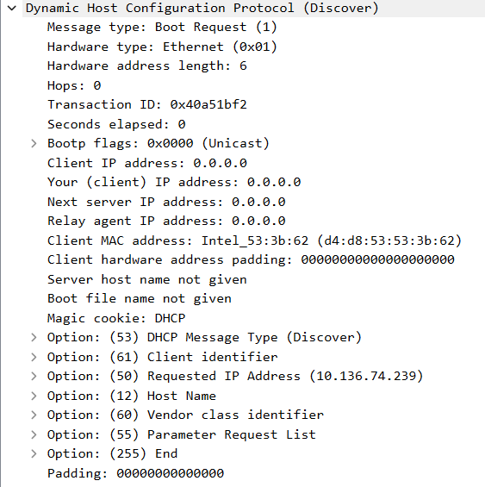

DHCP – OFFER:

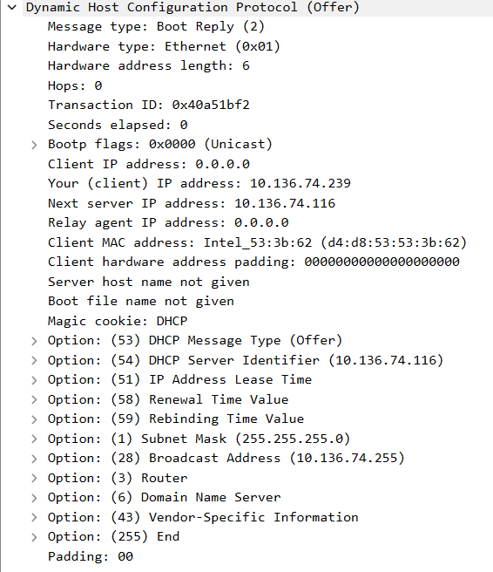

DHCP – REQUEST:

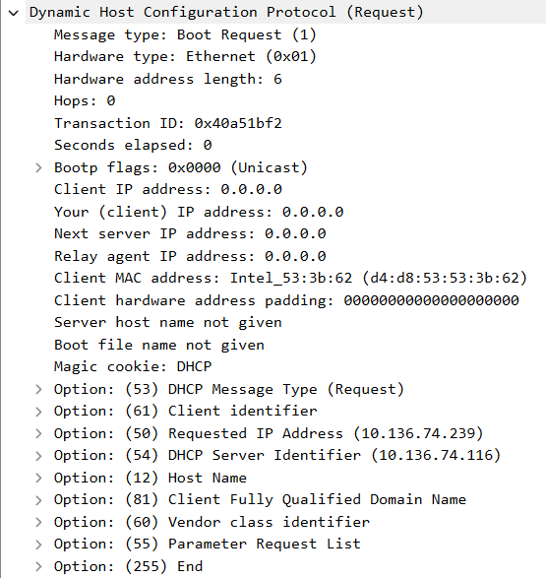

DHCP – ACKNOWLEDGE:

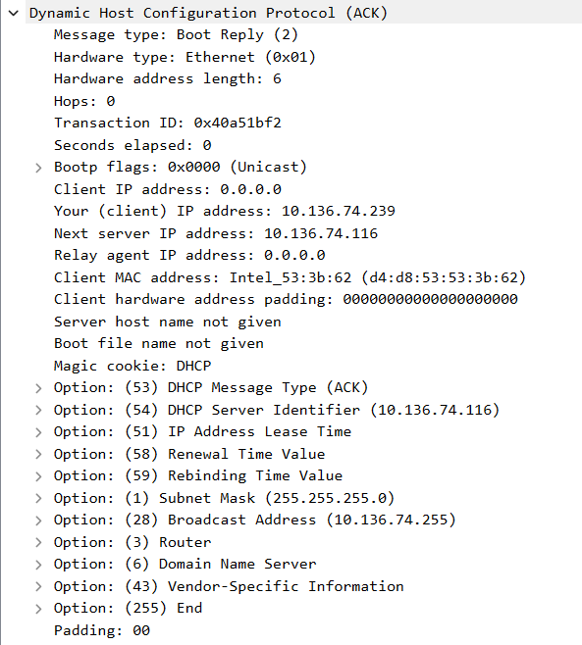

- Given an IP address range of 192.168.1.0/24, divide the network into 4 subnets.
Task:
Manually calculate the new subnet mask.
Calculate the range of valid IP addresses for each subnet.
Assign IP addresses from these subnets to devices in Cisco Packet Tracer.
Verify connectivity using ping between them.
Calculation of new subnet mask:
Network: 192.168.1.0/24
Number of subnets required = 4
/24 = 11111111.11111111.11111111.00000000
Subnets needed = 4,
So 2^n = 4 = 2^2, Therefore, n = 2
/24 + n = /24 + 2 = 26
Therefore subnet mask: /26 = 11111111.11111111.11111111.11000000 = 255.255.255.192
Calculating the range of valid IP addresses for each subnet:
Block size = 256 − 192 = 64
Subnet | Network Address | First IP | Last IP | Broadcast
1 | 192.168.1.0 | 192.168.1.1 | 192.168.1.62 | 192.168.1.63
2 | 192.168.1.64 | 192.168.1.65 | 192.168.1.126 | 192.168.1.127
3 | 192.168.1.128 | 192.168.1.129 | 192.168.1.190 | 192.168.1.191
4 | 192.168.1.192 | 192.168.1.193 | 192.168.1.254 | 192.168.1.255

Subnet 1: 192.168.1.1 – 192.168.1.62
Subnet 2: 192.168.1.65 – 192.168.1.126
Subnet 3: 192.168.1.129 – 192.168.1.190
Subnet 4: 192.168.1.193 – 192.168.1.254
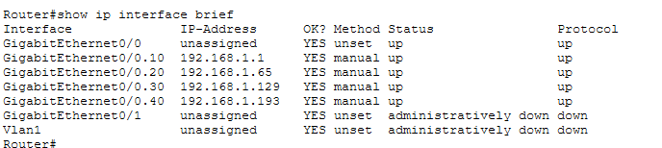

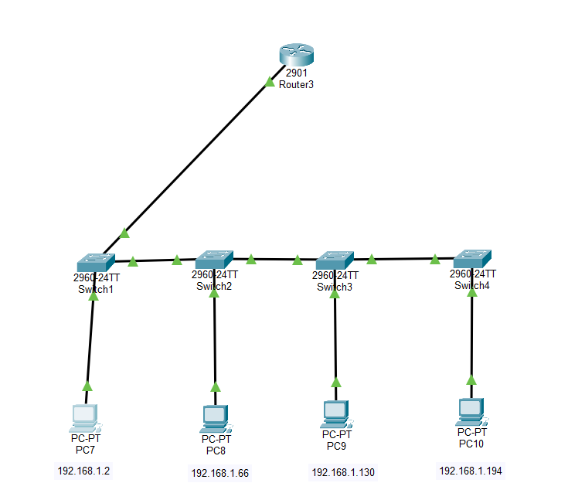
Pinging the Gateways:
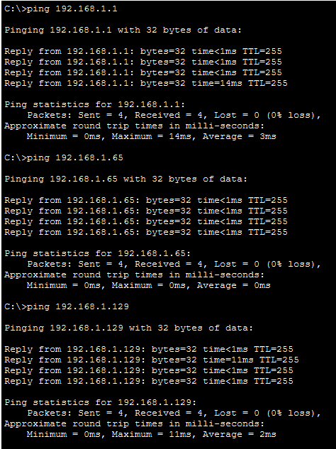
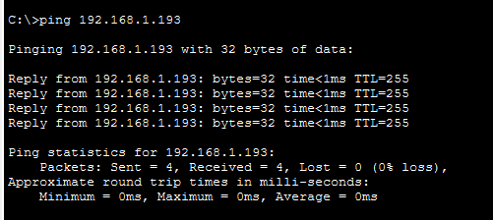
Pinging the PC’s:
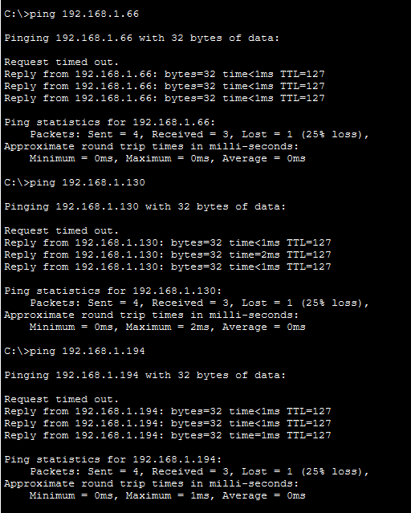

The network 192.168.1.0/24 was subnetted into four subnets using a /26 subnet mask. Each subnet was assigned to a separate VLAN. Access ports were configured for PCs and trunk links were configured between switches to carry VLAN traffic. A router was configured using router-on-a-stick with subinterfaces for each VLAN to perform inter-VLAN routing. Connectivity between devices in different subnets was verified using ping.

- You are given three IP addresses:
10.1.1.1
172.16.5.10
192.168.1.5
Task:
Identify the class of each IP address (Class A, B, or C).
What is the default subnet mask for each class?
Provide the range of IP addresses for each class.
class of each IP address (Class A, B, or C).
10.1.1.1 : Class A
172.16.5.10 : Class B
192.168.1.5 : Class C
Default subnet mask:
Class A: 255.0.0.0
Class B: 255.255.0.0
Class C: 255.255.255.0
IP Address Class Ranges:
Class A: 1.0.0.0 – 126.255.255.255
Class B: 128.0.0.0 – 191.255.255.255
Class C: 192.0.0.0 – 223.255.255.255

- In Cisco Packet Tracer, create a small network with multiple devices (e.g., 2 PCs and a router).
Use private IP addresses (e.g., 192.168.1.x) on the PCs and configure the router to perform NAT to allow the PCs to access the internet.
Task:
Test the NAT configuration by pinging an external IP address from the PCs and capture the traffic using Wireshark.
What is the source IP address before and after NAT?
CISCO PACKET TRACER:
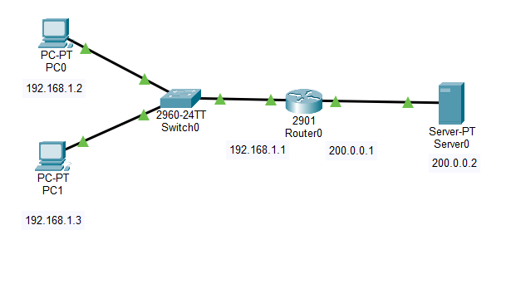
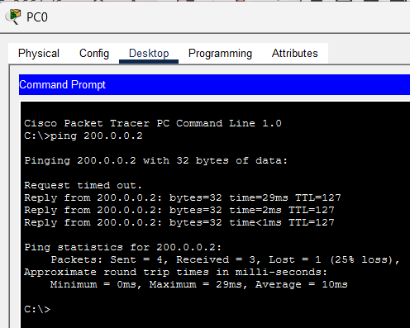

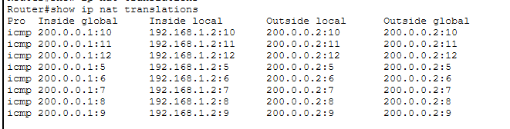
Source IP address before NAT : 192.168.1.2
Source IP address after NAT : 200.0.0.1
NAT translates private IP to public IP.

WIRESHARK:

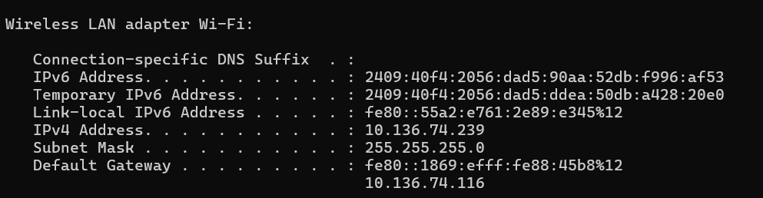

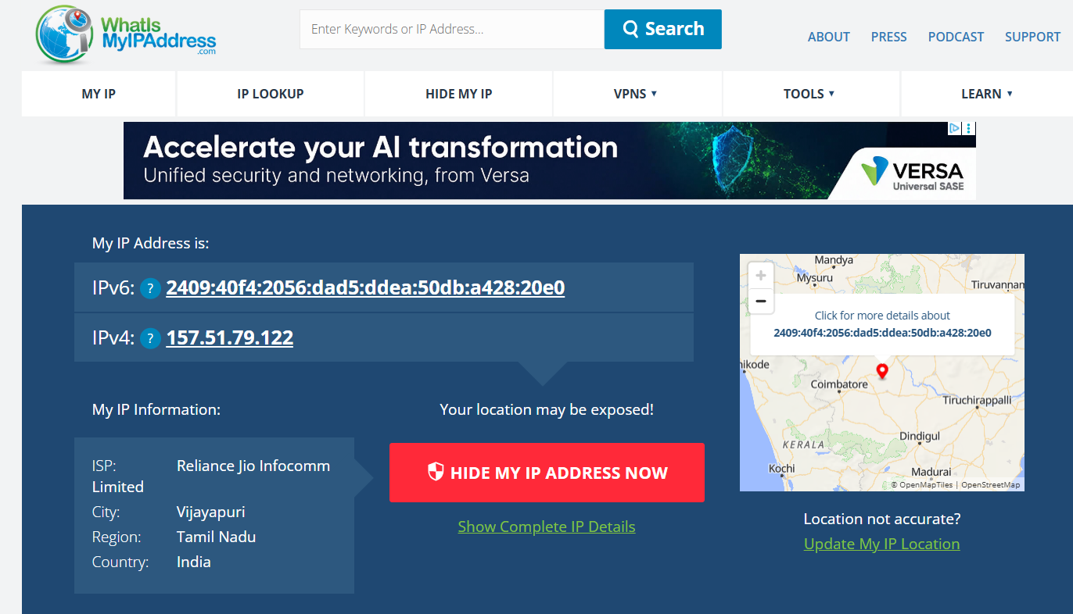

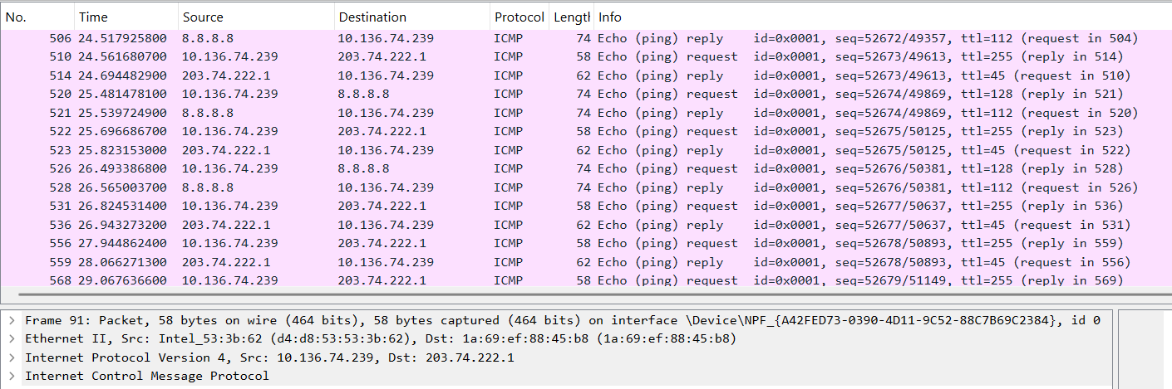

Before NAT | 10.136.74.239 (Private IP address)

After NAT | 157.51.79.122 (Public IP address)

